**Q7. You have a Cisco switch and a VoIP phone that needs to be placed in a voice VLAN (VLAN 20). The data for the PC should remain in a separate VLAN (VLAN 10). Configure the switch port to support both voice and data traffic.**

**Network setup:**

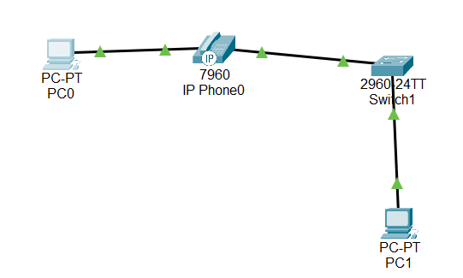

**Configuring switch:**

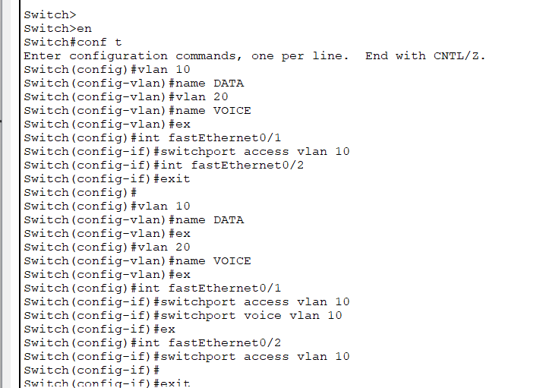

**VLAN table:**

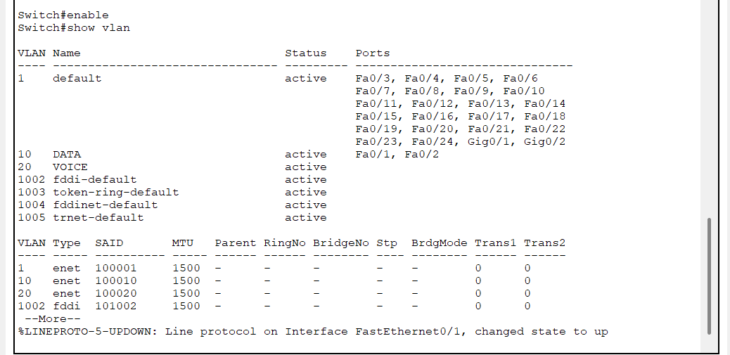

**Ping PC0 to PC1:**

